# Part Two

## Goal – Complete a program to order an array of strings.

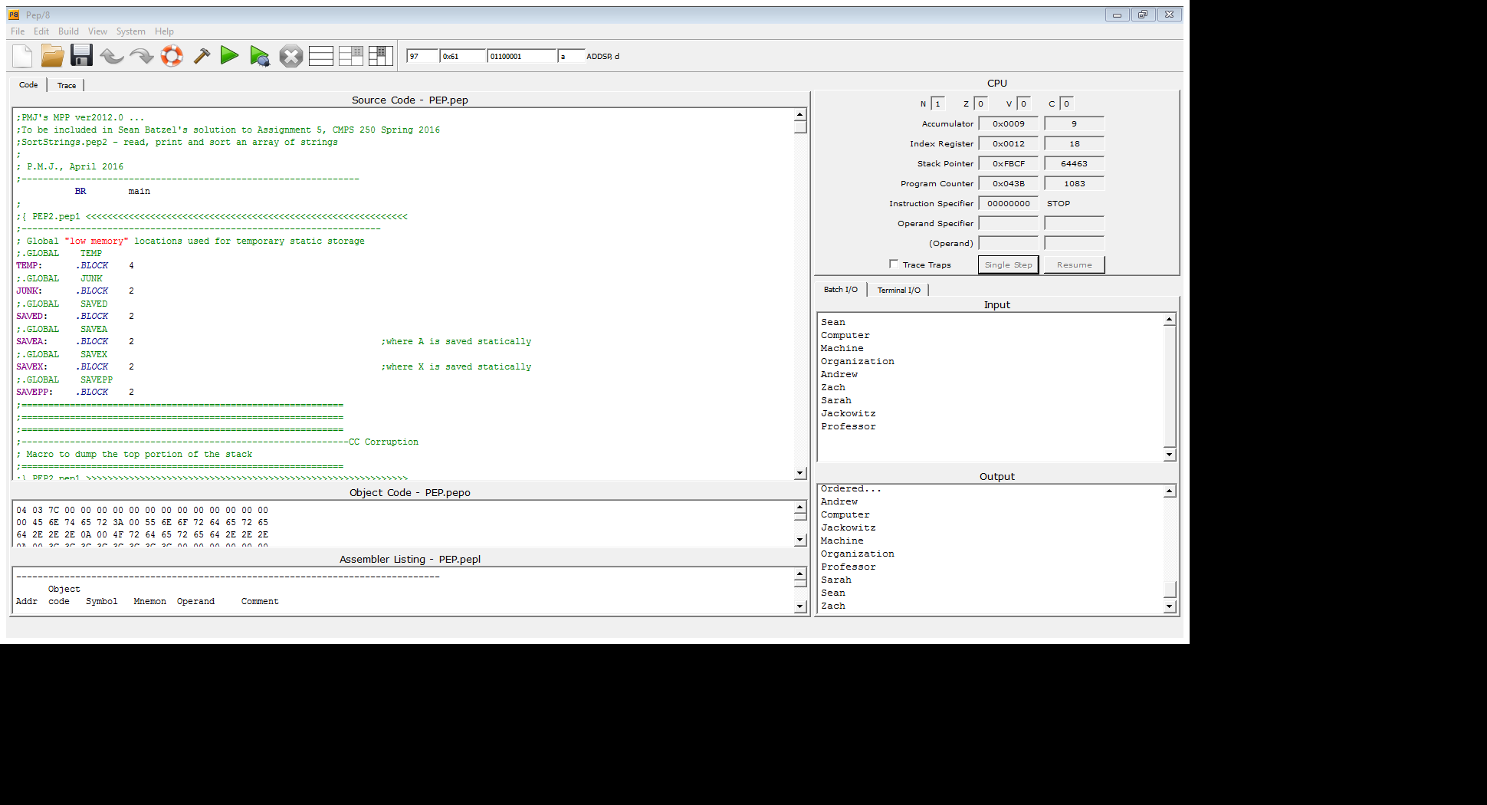

The program runs through the entire array of input strings, comparing each in a bubble sort until it sees that everything is in the right order. It then prints out the entire array in order.

## Known Issues

There shouldn’t be any in this program.